CONTACTS
Pastor Logan Zepp Pastor Jacey Zepp
Cell: 360-346-6753 Cell: 618-445-1520
Email:pastor.logan@gmc62033.com
Email:pastor.jacey@gmc62033.com
Gillespie Methodist Church
900 W. Broadway, PO Box 207, Gillespie, IL 62033
Church website: gmc62033.com
Email: gmc@gmc62033.com

Last Week’s 11/16/2025 Stewardship Giving ATTENDANCE:
November Q’s- Joyful Angels 9 am. Service – 69
Offering $ 1,596.00 Cool Kids Church - 11
Mission Q’s $ 39 .00 Sunday School – 35
Reimbursement $ 156.00
Total Deposit $ 1,771.00

Liturgist, Greeters, Ushers, and Acolytes
Liturgist Today: Jeff Bethard Nov. 30th Liturgist: Jeff Bethard
Greeters Today: Mary & Norm Engelke Nov. 30th Greeters: Scott & Tricia Coleman
Ushers Today: Mary & Norm Engelke, Nov. 30th Ushers: Phil Claro, Deanna Lowry
Susan Rose, Ada Peterson Mark & Brenda Lowe

Gillespie Methodist Church
Gillespie, Illinois

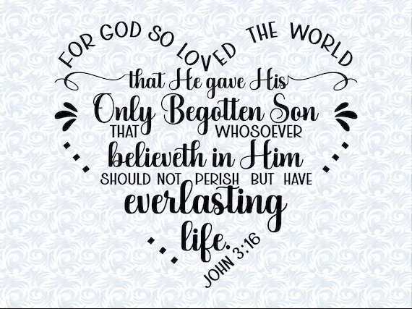

November 23, 2025
FAITH IN ACTION

PRELUDE Bringing in the Light of God’s Presence
WELCOME & OPENING PRAYER
CALL TO WORSHIP
*Hymn # 191 Jesus Love Me
* Video Here I Am to Worship by Chris Tomlin
♥Pastors Moment with the Kids
*♥ Cool Kids Blessings
JOYS & CONCERNS
PASTORAL PRAYER & LORDS PRAYER
*SCRIPTURE John 3:16-21
MESSAGE “The Greatest Gift”
OFFERING
*DOXOLOGY Hymn # 95
ANNOUNCEMENTS
*Video Blessed Be Your Name by Matt Redmon
*BENEDUCTION & POSTLUDE, (please remain standing until the acolyte, with the Light of God’s Presence, liturgist, and pastor finish the procession down the aisle while the postlude plays, thank you.) Copyright License # 22204768/222047

OPPORTUNITIES FOR THE WEEK

Monday Bible Study @ 1:00-2:00 p.m.

Up Coming Events:
Saturday December 13th – Joyful Angels Toy Drive at United Community Bank @ 12:30-2:30 PM.
Friday December 12th – Set up for Joyful Angels in fellowship hall 10:00 – ?.
Sunday December 14th - Children’s Christmas Program during the 9:00 AM service. Please have your child at the church by 8:30 AM on the 14th.
Sunday December 14th – O Holy Night Live Nativity, please see the insert for information on place, time, and directions.
Wednesday December 10th – GMW Christmas Luncheon, please see Brenda Lowe or any GMW lady for tickets. Set up for luncheon will be on Dec. 9th.

PRAYER LIST
Stacey Keck, Morgan Laughlin, Marty McCormack, Linda & Dennis Kahl, Jean & Joe Redolfi, Rita Spencer, Donna Easton, Logan Bethard(Pvt2 Logan is at a deployed location), Ashley Bryarly, Dylan Mason(Deployed), Dixie Lamparter, BJ & Darlene Gregory, Phil Kelmel, Tim Lockwood, Annabelle Griffel, Jason Schalk, Jeff Clark, Trudy Strieker, Laura Voss, Nancy Robke, Kim Inniss, Sam Robbins, Lisa’s Aunt Patti, Dementia/Alzheimer’s and their caregivers, Rodney Stoddard, Cora Lewis (high risk pregnancy), Joan Bellum, those battling cancer, addiction & depression, Our Nation, First Responders/our Military Personal, the Middle East, unspoken, unsaved, loneliness during the Holidays, Rick (kidney transplant), Bruce Clemonds, Families of Donald Swann, Mary Campbell, Debra Whitmire



