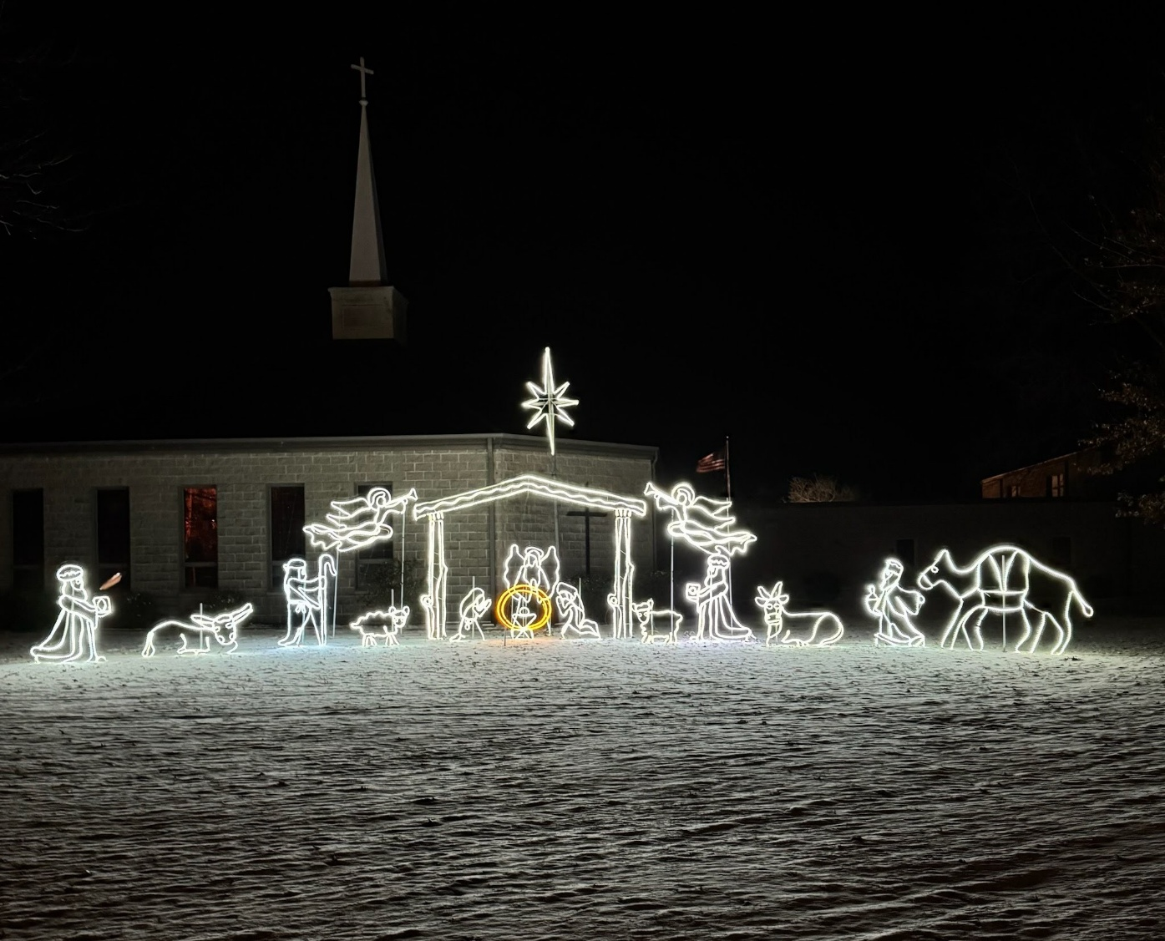

Gillespie Methodist Church
December 24, 2025
Christmas Eve Service

PRELUDE Bringing in the Light of God’s Presence

WELCOME & OPENING PRAYER

ADVENT WREATH CEREMONY Dave & Mary Griffel

CALL TO WORSHIP
Pastor: My soul proclaims the greatness of the Lord,
People: my spirit rejoices in God my Savior, who has looked with favor on
me, a lowly servant.
Pastor: From this day all generations shall call me blessed:
People: the Almighty has done great things for me and holy is the name of
the Lord, whose mercy is on those who fear God from generation to
generation.
Pastor: The arm of the Lord is strong and has scattered the proud in their conceit.
People: God has cast down the mighty from their thrones and lifted up the lowly.
Pastor: God has filled the hungry with good things and sent the rich empty away.
Unison: God has come to the aid of Israel, the chosen servant,
remembering the promise of mercy, the promise made to our forebears, to Abraham and his children forever.



*HYMN # 240 Hark the Herald Angels Sing
*HYMN # 234 O Come All Ye Faithful (verses 1-4)

1st SCRIPTURE READING Isaiah 9:1-7

PASTORAL PRAYER
*2nd SCRIPTURE READING Luke 2:1-21

PASTOR’S MESSAGE “Road Trip”

COMMUNION LITURGY Hymnal - Page 9-11

COMMUNION

CANDLELIGHT CERMONEY 1 Silent Night, Holy Night

